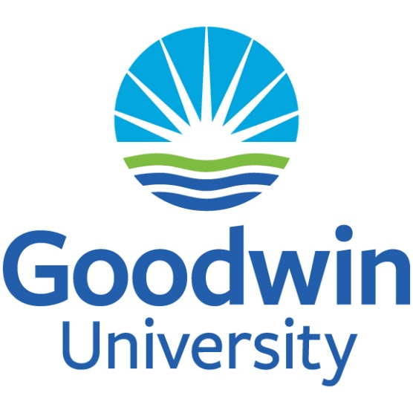

A Guide to Academic Assessment for program directors 2021-2026

Office of Institutional Effectiveness

The mission of Goodwin University is to educate a diverse student population in a dynamic environment that aligns education, commerce, and community. Our innovative programs of study prepare students for professional careers while promoting lifelong learning and civic responsibility. As a nurturing university community, we challenge students, faculty, staff, and administration to fully realize their highest academic, professional, and personal potential.
11.09.2021 nqw

Table of Contents
Introduction 3
Timeline for Getting an Assessment Project done 4
Overview 4
Curriculum Maps 5
Introduction 5
How to Write the Annual Program Assessment Report 7
Introduction 7
Process 7
Annual Assessment Report: Plan (due in the Fall) 8
Section 1: PLAN (Complete in Fall) 8
Section 2: IMPLEMENT (Complete in Fall) 9
Section 3: ASSESS (Complete: Winter/Spring) 9
Section 4: REVISE (Complete: Summer) 9
Appendices to submit with Annual Program Review Report 9
The Five-Year Review Process 10
Introduction 10
Process 10
Formal Program Review Report 11
Assessing the Current Situation and Planning Change for Improvement 11
Levels of Assessment and Department Responsibilities 13
Knowing What to Assess 14
Methods 14
Glossary 15
APPENDICES 16
Appendix A: Curriculum Mapping Template 17
Appendix B: Annual Program Assessment Report Template 19
Appendix C: Five-Year Program Assessment Report Template 21

Introduction
All academic programs at Goodwin University (Associate’s, Bachelor’s, Master’s Degree, and Doctoral programs) are assessed on an annual basis to ensure that students are being adequately prepared to pursue careers in their chosen fields, and to ensure the academic integrity and the overall quality of certificate and degree programs at the University.
To that end, each program must submit an annual program review summary to the Office of Institutional Effectiveness (OIE) at the Goodwin University.
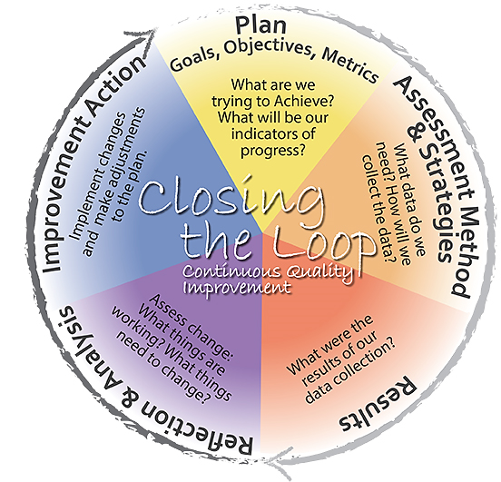
In addition, each program will submit a formal five-year review, in accordance with the formal review schedule created with the Department Chairs and provided by the Office of Institutional Effectiveness.
For those programs with professional accreditation, site visit reviews are acceptable in place of a formal five-year review. After the Office of Institutional Effectiveness receives the formal review, the University Committee on Assessment will review it.
For both annual and five-year reviews, the Office of Institutional Effectiveness will serve as a resource for program directors and department chairs.
Figure 1. Program-Level Assessment.

Timeline for Getting an Assessment Project done

Overview
The process for academic assessment occurs as a manageable project throughout the academic year to facilitate sustainability. The following table summarizes the assessment activities that will occur throughout the year.
Time Period | Assessment Activity
September – October | - Update Curriculum Map by ensuring alignment between course learning outcomes, catalog student learning outcomes, and specialized accreditation standards.  - Start thinking about Assessment Project for the current Academic Year.
October – November | - Write Section 1: PLAN of the Assessment Report Template.  - Determine what in the curriculum went well in the previous years and where there is room for improvement in the program.  - Decide upon a project where student performance can be improved.  - Establish which program learning outcomes this project would be related to the project.  - Write Section 2: IMPLEMENT of the Assessment Report Template.  - Determine what evidence will be gathered to assess this project as well as what tool (e.g., rubric, scoring guide, etc.) will be used.  - Determine the sample of students assessed and the key assignment (related to a program learning outcome) that will be assessed.  - Expect what biases may be at play with the assessment project.
December – May | - Write Section 3: ASSESS of the Assessment Report Template.  - Implement the assessment project.  - Collect data on the assessment project.  - Review the results and data analysis.
June - August | - Write Section 4: REVISE of the Assessment Report Template.  - Share results with faculty, advisory board members, or other members of the institution for feedback and ideas for improving curricula.  - Come up with a plan and or implement changes to the curriculum for improvement.  - Answer section 4 of the assessment report for documentation  - Suggestion:  - Write a summary of the assessment project for the program’s five-year review table to save time for the future review.

Curriculum Maps

Introduction
A curriculum map is a tool that indicates which program learning outcomes are taught in various courses throughout the academic program. In other words, as outlined in a table, there should be alignment between course outcomes, program learning outcomes, and institutional learning outcomes. An example of a curriculum map format is on the next page and is Appendix A.
All academic departments at Goodwin University complete a curriculum map at the beginning of the academic year. Updates and revisions to the curriculum map are made on an annual basis to reflect curricular changes made in the academic program.
Updating the curriculum map regularly allows for a program to avoid curricular drift. Curriculum drift is defined here as a process whereby the learning experiences associated with a curriculum do not match the specific syllabus, vision, or intentions associated with attaining desired course or program outcomes. Curriculum drift happens when a program team believes that they are teaching certain concepts related to the program outcomes in their courses, but they are not teaching the concept(s) in the course because of changes that were made to the course over the years or for other reasons.
The next page provides an example curriculum map that program leadership could use. (Template is Appendix A.)
Curriculum Alignment (Map) with Program Outcomes,
Institutional Learning Outcomes, and Key Assignments (2021-22)

Course | Program Outcomes | If applicable  Specialized Accreditation Standards | Key Assignment
Example Course 101 | 1, 5, 7 | 4, 8, 9 | Example Assignment
Student Learning Outcomes used in Assessment
Program Learning Outcomes (examples)
- Communication: Students will be able to effectively express and exchange ideas through various modes of communication including written, oral, and digital.
- Information Literacy: Students will be able to identify relevant information, evaluate alternatives, synthesize findings, and apply solutions.
- Career Readiness: Students will be able to apply their knowledge, skills, and abilities in their chosen field of study.

NOTE: Template is Appendix A

How to Write the Annual Program Assessment Report

Introduction
All academic departments at the Goodwin University complete an annual review process that culminates in a written report submitted to OIE. Review of the assessment reports is one way that the University evaluates the learning outcomes of its educational programs; collects evidence that supports achievement of outcomes; and develops plans for improvement based on the analyses. We recommend Program Directors select two or three program outcomes to evaluate each year to evaluate all program outcomes over a five-year period. This decision should be reflected in the five-year academic plan as well.

Process
Typically, a department will complete the annual report in two stages. Each department begins by assessing the current situation and deciding how to select and gather evidence on at least one student learning outcome (report sections 1-2) and then, upon completion of the assessment activity, the department discusses the results and develops an action plan (report sections 3-4).

Annual Program Review Report: Full Report Template is Appendix B.
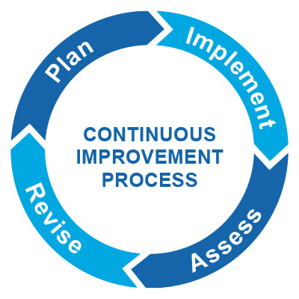
This document describes the information contained in the report sections.
Section 1: PLAN (Complete in the Fall)
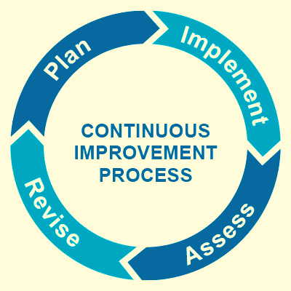
- Program and Contact Information
- Reflections on what was working and not working in years prior
- Student Learning Outcomes Being Assessed
Section 2: IMPLEMENT (Complete in the Winter/Spring)
- Data that is to be collected
- Methods for Assessment
- Potential Biases
- Faculty involved
Section 3: ASSESS (Complete in the Winter/Spring)
- Reflection on Results: Strengths and Weaknesses
Section 4: REVISE (Complete in the Summer)
- Changes made to the Curriculum based off Assessment Results
NOTE: Template is Appendix B

Annual Assessment Report: Plan (due in the Fall)
- Program and Contact Information
Indicate the pertinent information, such as the date and department being reviewed, as well as the name of a contact person, their phone number, and e-mail address.

- Student Learning Outcomes Being Assessed
In this section, identify two-three specific outcomes that are the focus of the review.

You will notice a table for each academic year. We strongly suggest deciding ahead of time when certain program outcomes will be assessed over the next five years. We recommend ensuring that various two-three different outcomes are assessed over the five years, so that each academic catalog program outcome is assessed at least once.

If there is ever a point where program learning outcomes are updated and changed, the program leadership does not have to assess all the previous outcomes over a five-year period; in this case, program leadership can start their assessments anew with the new program learning outcomes.

Section 1: PLAN (Complete in Fall)
This section asks program leadership to reflect on what went well or not so well in the previous academic year. This section also asks leadership to consider what kind of assessment project they would like to do for the upcoming academic year. The project should have to do with the continuous improvement of the curriculum. The project should also be aligned with two to three of the academic program’s learning outcomes from the academic catalog.
      - What was working for your program last year?
- What was not working for your program last year?
- What kind of project can you work on to improve student performance on your program learning outcomes?
- What program learning outcomes would be the focus of this project?

Section 2: IMPLEMENT (Complete in Fall)
In this section, complete the description of the evidence that will be used to complete the review.

Here, you will also describe how you will collect evidence to complete the review.
- How will you gather the data based off the variables identified in the section below?

For example, to better assess your program’s strengths and weaknesses, what information will need to be gathered to answer the following questions in the next section:
- What evidence will you collect to assess in this project?
- Who is your sample?
- What are some potential biases that could be a part of this assessment project? Are there any ways that we could minimize biases?
- What kind of tool are you using for your assessment (e.g., rubric or scoring guide)? Describe the elements of this tool.
- Will assessment be blind? If not, consider that this may be a weakness.
- Who will be involved in the assessment plan?

Section 3: ASSESS (Complete: Winter/Spring)
By this time, you should have completed your assessment project, gathered your data, and analyzed it. Now that you have completed your assessment, discuss what was learned because of your assessment efforts. You will answer the following questions:
- What were the results of the academic assessment process?
- What were some strengths? What were some weaknesses?
- What surprised you?
- What were some areas that the program needs to continue to watch?

Section 4: REVISE (Complete: Summer)
This section answers the question “What do we want to work on to better achieve program goals and outcomes?”. This section asks more information on how you are going to close the loop. You will be asked to answer:
- Where are you improving your program?
- What did your adjuncts/faculty/advisory board members think of the results? What were their suggestions?
- How will you use these results to improve your academic program/curriculum?

Appendices to submit with Annual Program Review Report
Provide the most up-to-date curriculum map and submit any additional supporting documentation.

The Five-Year Review Process

Introduction
All academic departments at Goodwin University University complete a formal review process every five years. Formal program review is one way the university evaluates the learning outcomes from all its programs; collects evidence as to whether these outcomes are achieved; and develops long-range plans for improvement based on the analyses.
The five-year process documents the summative and formative, ongoing assessment process for each program over the prior four (4) years. The final report lists all program outcomes, documents any changes in the outcomes or curriculum map, indicates the cycle of assessment of each outcome, and outlines the methods that were used for assessment each year. The formal program review results should be used to:
- Review a program’s mission and goals
- Analyze evidence as to whether student learning outcomes and other department goals were achieved
- Review any projects that were implemented to improve a student learning outcome
- Revise student learning outcomes and other department goals
- Make long-range program planning and improvement decisions
- Allocate resources (i.e., budget requests)

Process
A department completes the program review process in two stages over several semesters: (1) each program begins by gathering evidence of student learning based off the achievement of program learning outcomes from the academic catalog, (2) the program then devises a plan for improvement based on the evidence gathered. Details of this process are outlined in an earlier section, “How to Write the Annual Assessment Report”. As aforementioned, the first two stages are typically completed in the fall and the second stages are completed in the spring or summer.
If the program maintains professional accreditation, then a summary of the site visit, report and resulting action plan can be provided in the five-year report. Such documentation can only be used once in a five-year period (for example, if the professional accrediting body only requires a formal report every five or every ten years, the department cannot use the same report twice in a row to satisfy the five-year formal review requirement. The department will be required to use Goodwin University’s formal review process, in that case).

If your department chair uses a more detailed formal review process, then submit the more detailed report in place of the Goodwin University five-year review template. OIE encourages the Program Director to review the formal assessment report format with their Dean or Associate Dean, so that the process and records are useful to the academic department.
The requirement of completing a formal program review is not optional; however, there is plenty of flexibility within the process to accommodate each department’s unique needs.
When the five-year report is completed, an academic program representative will discuss it in several venues: during a University Committee on Assessment meeting or a department meeting.

Formal Program Review Report
Just like the annual assessment report, the five-year report is due at the end of the academic year in August.
- Department Mission and Background
- Student Learning Outcomes and Other Department Goals
- Summary of Annual Assessment Activity as well as Analysis of Strengths and Weaknesses, Lessons Learned/ Changes Made
- Student Trends
- Faculty Trends
- Department’s Capacity to Support the Plan and/or Resources Needed
- Appendices (additional material necessary to support findings and recommendations)

Assessing the Current Situation and Planning Change for Improvement
The five-year review begins with evidence that the department already has. Later, the five-year report asks the program to create plans for improving the achievement of student learning outcomes and other goals.
- Program Information
This section should include contact information (i.e., date and department/program being reviewed, as well as the name of a contact person, phone number, and email address).
- Program Purpose
This section describes the department’s program learning outcomes, as well as program mission, and how it supports the university’s mission. This section and the next section provide insight into where the department wants to be and what it plans to accomplish.
- Curriculum
This section describes student learning outcome and program learning outcome alignment to courses and major key assignments. This section is intended to help program leadership determine how courses relate and flow into one another in terms of course content. It is also a story of how the academic program evolved over five years and is continuing to evolve. The section talks about current strengths and challenges, as well as ideas for how to build upon those challenges. Towards the end of this section, the program is asked to consider lessons learned and potential changes for the future.
- Summary of Annual Academic Assessment Activity
This section summarizes the assessment projects that took place over the last five years. This table would summarize what program outcomes were assessed a specific year, what methods were used to gather the data, summary of any key performance indicators, data results, as well as updates and changes made to the curriculum.
- Students
In this part, program leaders are asked to reflect on trends related to students. You will have the opportunity to reflect on enrollment over the five years. Other trends may include job placement rates, exam pass rates, retention, or any other data you may have available. You will also reflect on any characteristics about the students that may impact their learning (e.g., adult learners may have trouble coming to class at certain hours of the day because of work). The department will have the opportunity to reflect on how they can respond to student trends.
- Faculty
In this part, program leaders will review current faculty and how they contribute to program goals. This section is not meant to penalize or scrutinize any faculty. Rather, it is intended to look for opportunities for professional development.
- Analysis of Strengths and Weaknesses, Lessons Learned
At this point, the department analyzes the assessment data gathered from the last five years, identifies strengths and weaknesses, makes recommendations, designs a related action plan, and determines the capacity of the department to support the action plan.
- What are some of the “lessons learned”? For example, what will you do differently next time? Indicate how your formal program review results will be linked to next year’s annual review process.
This section also answers the question “How well are we doing?” As a department, discuss and evaluate the results of the assessment data gathered from the last five years. Describe when the discussion took place, who participated and what you discovered that works and does not work.
- What plan can we have in place to ensure that the program can continue to better meet program goals.
- Recommendations/Action Plan
In this section, answer the question
- “What do we want to work on to better achieve the goals?”
Describe 1-3 actions the department plans to undertake. For each action, indicate who is responsible and give a timeline for action.
- Department’s Capacity to Support the Plan and/or Resources Needed
In this section, evaluate the capacity of the department to achieve its goals, especially the action plan. For example, summarize and analyze information about your faculty, technology, space, and other resources. Give a realistic estimate of the additional internal and external resources needed to support the department’s action plan.
- Executive Summary
The final section is an Executive Summary that serves as a concise presentation of the program review process. The summary should be able to stand alone and should provide the reader with an overview of the process, relevant findings, resulting action plans, and resource analysis.
NOTE: Template is Appendix C

Levels of Assessment and Department Responsibilities
Course-Level Assessment: Program directors are responsible for course-level assessment.
Program-Level Assessment: Program directors, in conjunction with deans, are responsible for program-level assessment.
Institution-Level Assessment: The Office of Institutional Effectiveness (OIE) is responsible for institution-level assessment.

Department Responsibilities
Each department is responsible for assessing the data it collects. OIE can assist program directors with this assessment.
Program directors are responsible for compiling annual and formal reviews and submitting them to OIE.
OIE will send reviews to the University Committee on Assessment.
OIE will send a summary of the program reports to the Provost, Vice President of Academic Affairs, and the Department Chairs.
OIE will compare Goodwin University’s program assessment process and data with national and peer data, to understand where the University stands in relation to similar schools/programs.

Knowing What to Assess
According to Program-Based Review and Assessment: Tools and Techniques for Program Improvement, the first step in determining which assessment methods you will use in your annual and formal reviews is knowing what you want to assess. When assessing student learning, the following areas are examined: 1. Knowledge of the discipline (What do students know?), 2. Skills (What can students do?), 3. Values (What do students care about?).
“When developing assessment methods, make sure your selections:
- Answer questions that are important to you;
- [think of which program or student learning outcome you want to measure];
- are manageable, given available resources (including time and money), and
- result in useful feedback that highlights accomplishments and identifies areas requiring attention.”
Adapted from California State University, Bakersfield, PACT Outcomes Assessment Handbook (1999)

Methods
The following methods are taken from Program-Based Review and Assessment:
- The evidence you collect depends on the questions you want to answer
- Use multiple methods to assess each learning outcome
- Include both direct (student performance on actual assignments) and indirect measures (student understanding of how well they did in the program, e.g., surveys)
- Include qualitative (e.g., student reflections) as well as quantitative measures (e.g., collective review of how a class scored on a rubric)
- Choose assessment methods that allow you to assess the strengths and weaknesses of the program
- Be selective about what you choose to observe or measure
- Use capstone courses or senior assignments to directly assess student learning outcomes
- Enlist the assistance of assessment and testing specialists when you plan to create, adapt, or revise assessment instruments, and
- Use established accreditation criteria to design your assessment plan.

Glossary
Curriculum Mapping – “Curriculum mapping provides an inventory of the link between your objectives and the curriculum. It can also serve as a catalyst for discussions about the proper sequencing of coursers, the degree to which the curriculum really supports student learning, and the extent to which core objectives are appropriately addressed within the curriculum.” Curriculum maps will detail the courses in which learning objectives/program outcomes are: introduced (I), reinforced (R), and evaluated (E).
Direct Assessment – involves looking at student work: objective tests, essays, presentations, and classroom assignments. Direct assessment should be used as much as possible when assessing the effectiveness of student learning outcomes.
Indirect Assessment – involves looking at student reflections on their own learning, such as surveys focus groups and interviews.
Formative Assessment—involves assessing student learning as the semester goes on. For example, you may assess how students are learning a concept learned in class and may do a quiz to see how students are retaining information and which topics may have challenges.
Summative Assessment—involves assessing students’ performance after the end of a semester course. This kind of assessment could be a final project.
Qualitative Data—this kind of assessment gathers information that cannot be easily translated into numbers. This kind of information might be anecdotes from interviews, focus groups, or open-ended survey questions.
Quantitative Data—this kind of assessment collects data that can easily be analyzed using numbers. This kind of data includes key performance indicators, number of students that responded to a specific option on a survey, etc.

APPENDICES

- Curriculum Mapping template
- Annual Program Assessment template
- Five-year Program Assessment template
Note: Word Templates of the above documents will be sent via email

Appendix A: Curriculum Mapping Template

Goodwin University Curriculum Mapping/ Alignment with Program Outcomes
and Key Assignments (2021-22)

Course | Program Outcomes | If Applicable Specialized Accreditation Standard(s) | Key Assignment

Student Learning Outcomes and Accreditation Standards used in Assessment

Program Learning Outcomes (examples)
- Communication: Students will be able to effectively express and exchange ideas through various modes of communication including written, oral, and digital.
- Information Literacy: Students will be able to identify relevant information, evaluate alternatives, synthesize findings, and apply solutions.
- Career Readiness: Students will be able to apply their knowledge, skills, and abilities in their chosen field of study.

Appendix B: Annual Program Assessment Report Template

Assessment of Student Learning, Annual Program Report 2021-2022
19
Program/Department:
School: Dean:
Director:
Degree:

Years | Program Outcomes Assessed for this Academic Year
Academic Year 1: 2021 - 2022
Academic Year 2: 2022 - 2023
Academic Year 3: 2023 - 2024
Academic Year 4: 2024 - 2025
Academic Year 5: 2025 - 2026

Section 1: Plan (Complete in the Fall)
- What was working for your program last year?

- What was not working for your program last year?

- What kind of project can you work on to improve student performance on your program learning outcomes?

- What program learning outcomes would be the focus of this project?

- Which Institutional Learning Outcome may be tangentially or indirectly involved?
Section 2: Implement (Complete in the Winter/Spring)
- What evidence will you collect to assess in this project?

- Who is your sample?

- What are some potential biases that could be a part of this assessment project? Are there any ways that we could minimize biases?

- What kind of tool are you using for your assessment (e.g., rubric or scoring guide)? Describe the elements of this tool.

- Will assessment be blind? If not, consider that this may be a weakness.

- Who will be involved in the assessment plan?
Section 3: Assess (Suggestion: Winter/Spring)
- What were the results of the academic assessment process?

- What were some strengths? What were some weaknesses?

- What surprised you?

- What were some areas that the program needs to continue to watch?

Section 4: Revise (Suggestion: Summer)
- Where are you improving your program?

- What did your adjuncts/faculty/advisory board members think of the results? What were their suggestions?

- How will you use these results to improve your academic program/curriculum?

Appendix C: Five-Year Program Assessment Report Template

Assessment of Student Learning, Five Year Assessment Report 2021-2026
- Program/Department:
School: Dean:
Director:
Degree:

- Program Purpose
Behind every successful academic program, there is a clear mission and vision driving the program forward. In this section, we will reflect on the mission and program outcomes, as well as any changes that may have taken place.
- What is the mission of the academic program or the department? How does it support the University mission statement?

- What are the program learning outcomes?

- Have the program learning outcomes or mission statement changed between 2021-2026? If so, what process took place to change those outcomes/mission statement?

- Curriculum
As assessment takes place over time, changes are made to the curriculum for continuous improvement. This section asks the program director to summarize some of the changes made.
- Attach your most up to date curriculum map to this document.

- How are courses scaffolded in your program? In other words, how does one course complement another as one moves forward?

- What are areas of concern in the program? What are areas of strength in the program?

- Summary of Annual Academic Assessment Activity 2021-2026
This section summarizes the assessment project and findings from the assessment project performed on an annual basis. We suggest that you complete each section for the year after completing your academic assessment report on a yearly basis to save you time.

Academic Year 1: 2021 - 2022 | Results
Program Outcomes Assessed for this Academic Year
Methods for Gathering the Assessment Data of Program Learning Outcomes
Summary of Key Performance Indicators Gathered (e.g., graduation rate, exam pass rates, etc.)
Summary of Results of Assessment/Data Collection
Updates and Changes to Curriculum
Academic Year 2: 2022 - 2023
Program Outcomes Assessed for this Academic Year
Methods for Gathering the Assessment Data of Program Learning Outcomes
Summary of Key Performance Indicators Gathered (e.g., graduation rate, exam pass rates, etc.)
Summary of Results of Assessment/Data Collection
Updates and Changes to Curriculum
Academic Year 3: 2023 - 2024
Program Outcomes Assessed for this Academic Year
Methods for Gathering the Assessment Data of Program Learning Outcomes
Summary of Key Performance Indicators Gathered (e.g., graduation rate, exam pass rates, etc.)
Summary of Results of Assessment/Data Collection
Updates and Changes to Curriculum

Academic Year 4: 2024 - 2025
Program Outcomes Assessed for this Academic Year
Methods for Gathering the Assessment Data of Program Learning Outcomes
Summary of Key Performance Indicators Gathered (e.g., graduation rate, exam pass rates, etc.)
Summary of Results of Assessment/Data Collection
Updates and Changes to Curriculum
Academic Year 5: 2025 - 2026
Program Outcomes Assessed for this Academic Year
Methods for Gathering the Assessment Data of Program Learning Outcomes
Summary of Key Performance Indicators Gathered (e.g., graduation rate, exam pass rates, etc.)
Summary of Results of Assessment/Data Collection
Updates and Changes to Curriculum
- Students
Students are a vital component to the academic program at large. In this section, we will reflect on student trends and how the student body could affect curriculum.
- Complete the following table to summarize student enrollment:
 | Year 1: 2021-22 | Year 2: 2022-23 | Year 3: 2023-24 | Year 4: 2024-25 | Year 5: 2025-26
Enrollment

- What other trends are you seeing in relation to students? (e.g., job placement rates, exam pass rates, retention, etc.)

- Are there any characteristics related to students that could impact student learning?

- What plans does the department have in response to those trends?

- Faculty
Faculty heavily influence the content delivered to students. In this section, programs will be asked to reflect on how their faculty are helping meet program goals. This section is not meant to penalize or scrutinize any faculty. Rather, it is intended to look for opportunities for professional development.
- How do the qualifications, skills, and experience of the full time and adjunct faculty align with program student learning goals?

- What are the program’s goals for the faculty over the next five years?

- S.W.O.T. and Lessons Learned
At this point, the department analyzes the assessment data gathered from the last five years, identifies strengths and weaknesses, makes recommendations, designs a related action plan, and determines the capacity of the department to support the action plan.
- Share your results with your department, faculty, and/or advisory board. What lessons did you learn during this process from the five-year review? What feedback did you receive?

- What are the strengths of your program? What can your program do to continue the strengths of the program?

- What are some weaknesses of your program? What can your program do to address those weaknesses?

- What are some opportunities for your program to grow? How can you act on those opportunities?

- What are some threats that your program might face? How can we address those threats early on?

- Recommendations/Action Plan
In this section, answer the question “What do we want to work on to better achieve the goals?”
Describe 1-3 actions the department plans to undertake. For each action, indicate who is responsible and give a timeline for action.

- Budget
Academic programs need a strong and well thought out budget in the delivery of successful education.
- What initiative or additional resources would help improve the achievement of program learning outcomes?

- Executive Summary
The final section is an Executive Summary that serves as a concise presentation of the program review process.
- Describe the process, relevant findings, resulting action plans, and resource analysis.

