CO-CURRICULAR ASSESSMENT REPORT
Co-curricular Assessment, Annual Department Report 2021-2022
1

Department:

Director:

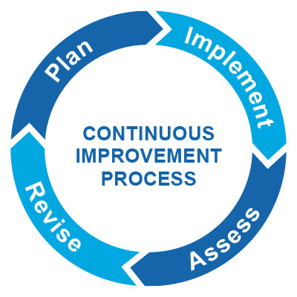 | Section 1: Plan (Please Complete in the Fall)  - How do your departmental activities fit either the University Mission statement or the mission statement for Student Services?  - What was working for your department last year?  - What was not working for your department last year?  - Where would you like your department to improve?  - What are you curious to learn more about, when it comes to your department?
Section 2: Implement (Please Complete in the Fall)

- What evidence will help you answer your burning question? How will you collect it?
- Who is your sample?
- What are some potential biases that could be a part of this assessment project? Are there any ways that we could minimize biases?
- What kind of tool are you using for your assessment (e.g., scoring guide, key performance indicators, focus groups, interviews, etc.)? Describe the elements of this tool.
- Who will be involved in the assessment plan?
- Who will look at the data with you once the data is collected?

Section 3: Assess (Please Complete: Winter/Spring)

- What were the results of the assessment process?
- What were some strengths? What were some weaknesses?
- Is the data directly reflective of programming? Are there other factors that could be influencing the data results?
- What surprised you?
- What were some areas that the department needs to continue to watch?

Section 4: Revise (Please Complete: Summer)

- What specific changes will you make to the way your department operates as a result of this data?
- What did your colleagues think of the results? What were their suggestions?
- How will you use these results to improve your department?

.

